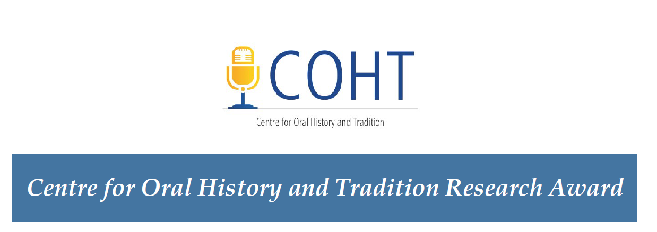

The Centre for Oral History and Tradition Research Award (COHTRA) aims to support Southern Alberta oral history research by University of Lethbridge faculty and their research teams, including graduate and undergraduate students and community affiliates. The award may be part of a larger project that includes colleagues at the U of L or elsewhere.
Eligibility:
Applications from all University of Lethbridge researchers are welcome, but please note that COHT reserves the right to make final eligibility determinations in line with university policies. The project itself must clearly involve oral history-based research.

Value and Duration:
The value of each award is capped at $5,000. Two awards will normally be offered per year. The usual term of an award is 24 months or less, in accordance with the applicant’s request.
Evaluation and Criteria:
A blind peer review will be conducted by an ad hoc committee struck by the executive of the Centre for Oral History and Tradition, University of Lethbridge, with emphasis on the following:
- Overall merit of the research proposal, including fit with the Centre for Oral History and Tradition’s research interests
- Originality and significance of the proposed research, including suitability of research strategies/methods, importance of the overall research program, and suitability of the timetable
- Likelihood of the project developing into a publishable paper or report
- Research record of the applicant/lead researcher
- Training of students and other research personnel, if applicable
- Justification of the proposed budget
- Pending ethical approval, preference will be given to applications that plan to deposit interview tapes and/or transcripts in an accredited public archive such as the Galt or the U of L Archives.

Submission and Dissemination Instructions:

Applications are due by May 30, 2021. Applications must be submitted online via the U of L Bridge Research Proposal Form. Please select “Internal Grant Application Form” under the Research Services tab on the Bridge, and attach your application as a .pdf to that form.

Successful applicants will be required to present their findings as part of the COHT Speakers’ Series.
For additional information or questions, contact Carol Williams carol.williams@uleth.ca

PROJECT TITLE:

APPLICANT(S):

ABSTRACT (max 250 words):
- Include a succinct description of the research written for an intelligent reader who is relatively uninformed in the field of study.
- Define the scope and limitations of the project.
- Comment on the potential significance of the study to the oral history of Southern Alberta and the applicant’s discipline.

DETAILED DESCRIPTION (max 4 pages):
Describe the proposed research in a narrative style with headings for the sake of clarity. The detailed description must not exceed four pages and must address the following points:

- Objectives: Define the topic to be researched clearly and concisely, providing any background information essential to understanding the importance of the work.
- Significance: Include a statement of the potential significance, future use, relevance or application of the results.
- Theory and Methodology: State the theoretical framework, the choice of methodology, the types of data to be collected, and the means of analysis to be employed.
- Resources: Indicate the resources required, personnel, facilities, equipment, materials, etc., with particular emphasis on those included in the budget.
- Implementation: State what is to be done, by whom (the researchers or other personnel), how, and when. For applications submitted by multiple applicants, indicate the role of each applicant in the proposed research.
- Dissemination and Access: Describe how the research will be disseminated and made accessible to other researchers.
- Literature Review: Include, where appropriate, references to similar or related work and comments on how the proposed project will extend the current literature.

PUBLICATIONS AND PRIOR RESEARCH (max 6 pages):
The Principal Investigator(s) must provide a short CV (no more than six pages) listing education, recent relevant publications, and prior research activity. Other members of the research team must be identified by name, title, affiliation, and contact information.

BUDGET (max 2 pages):
Provide a budget and concise justification. Personnel costs must include each employee's title and type of work to be performed, the estimated number of hours/months to be worked, and the rate of pay per hour/month plus 12% benefits. Travel costs must include the purpose of the travel for each destination, mode of travel, cost of meals and lodging, and the number of days of the travel.

OTHER FUNDING (max 1 page):
Provide information regarding other granting agencies or sources from which you have received, requested or plan to request funding for this research. Include the name of the granting agency, the status of request, and the amount requested or awarded.

BIBLIOGRAPHY (max 10 pages):

