Academic Plan

University of Lethbridge Applied Studies Academic Plan

Academic assignments are an essential component of this course, accounting for 50% of the total grade. You can have 1 to 4 academic deliverables in your plan (ex. paper(s), presentation(s), project(s), or other academically appropriate assignments).

Engage in thorough discussions with your Academic Supervisor to clearly understand the assignments' expectations, deadlines, weighting, and any other relevant details.

Utilize this platform, build and submit your academic plan. The plan is due 4 weeks after the start of the semester and should only be submitted after you have been registered for the course.

After you submit this form, it will be sent to your Work Integrated Learning (WIL) Instructor to review, and then to your Academic Supervisor to give their approval.

Once approved you will receive an email with a PDF of the plan that you will need to upload into MyExperience.

Contact your WIL Instructor if you have any questions about this process.

Note: Any changes to the Academic Plan need to be discussed with both the WIL Instructor and your Academic Supervisor.

Student's First Name
________________________________________________________________

Student’s Last Name
________________________________________________________________

Student’s University of Lethbridge Email
________________________________________________________________

Work Integrated Learning (WIL) Instructor
Brittany Lewis: brittany.lewis@uleth.ca
Chelsea Le Francois: chelsea.lefrancois@uleth.ca
Erin Kennett: erin.kennett@uleth.ca
Kyra Svrcek: kyra.svrcek@uleth.ca
Sheridan Macaulay: sheridan.macaulay@uleth.ca

Faculty Supervisor’s Full Name
________________________________________________________________

Faculty Supervisor’s Email
________________________________________________________________

Additional support/supervisors and their role in this plan (optional)
________________________________________________________________
________________________________________________________________
________________________________________________________________
________________________________________________________________
________________________________________________________________

Applied Studies Course Structure
In Applied Studies, students complete two connected components:
50% Academic Assignments: These are created by the student and the Academic Supervisor. 50% WIL Assignments: These are guided by the Applied Studies Instructor and include reflection, professional development, and a workplace experience component.

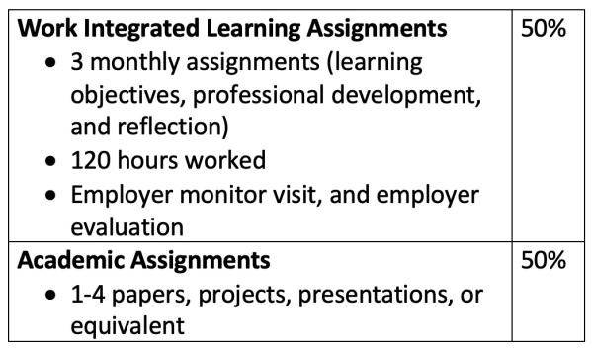
Applied Studies Rubric

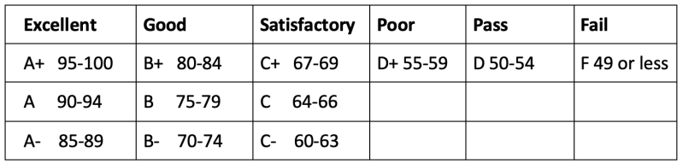

Additional file provided by Academic Supervisor (optional)
If your Academic Supervisor developed a plan for your academic assignment(s), please attach it here. Note: You will still need to provide the required information below.

Academic Assignment #1 (Required)
Provide a detailed description of the assignment(s) that make up your course. Provide the expectations, deadlines, format, content, methods, and other requirements. Be as specific and clear as possible.

Description Should Include:
- Type and format of assignment (e.g., paper, presentation, project)
- Detailed requirements, such as:
  - For papers: title or topic, expected word count, required headings or structure, and citation style
  - For presentations: slide count, time limit, and delivery format (live or recorded)
  - For projects: scope, components, and deliverables
- Draft deadlines and revision expectations (if applicable)
- Working bibliography or research sources, if relevant
- AI use expectations (e.g., permitted tools, disclosure requirements, or limitations)
- Grading information or assessment criteria, if known

Tip: Clear, upfront expectations help avoid confusion and support meaningful academic evaluation.
- Description __________________________________________________
- Deadline (mm/dd/yyyy) __________________________________________________

Academic Assignment #2 (Optional)
Provide a detailed description of the assignment(s) that make up your course. Provide the expectations, deadlines, format, content, methods, and other requirements. Be as specific and clear as possible.

Description Should Include:
- Type and format of assignment (e.g., paper, presentation, project)
- Detailed requirements, such as:
  - For papers: title or topic, expected word count, required headings or structure, and citation style
  - For presentations: slide count, time limit, and delivery format (live or recorded)
  - For projects: scope, components, and deliverables
- Draft deadlines and revision expectations (if applicable)
- Working bibliography or research sources, if relevant
- AI use expectations (e.g., permitted tools, disclosure requirements, or limitations)
- Grading information or assessment criteria, if known

Tip: Clear, upfront expectations help avoid confusion and support meaningful academic evaluation.
- Description __________________________________________________
- Deadline (mm/dd/yyyy) __________________________________________________

Academic Assignment #3 (Optional)
Provide a detailed description of the assignment(s) that make up your course. Provide the expectations, deadlines, format, content, methods, and other requirements. Be as specific and clear as possible.

Description Should Include:
- Type and format of assignment (e.g., paper, presentation, project)
- Detailed requirements, such as:
  - For papers: title or topic, expected word count, required headings or structure, and citation style
  - For presentations: slide count, time limit, and delivery format (live or recorded)
  - For projects: scope, components, and deliverables
- Draft deadlines and revision expectations (if applicable)
- Working bibliography or research sources, if relevant
- AI use expectations (e.g., permitted tools, disclosure requirements, or limitations)
- Grading information or assessment criteria, if known

Tip: Clear, upfront expectations help avoid confusion and support meaningful academic evaluation.
- Description __________________________________________________
- Deadline (mm/dd/yyyy) __________________________________________________

Academic Assignment #4 (Optional)
Provide a detailed description of the assignment(s) that make up your course. Provide the expectations, deadlines, format, content, methods, and other requirements. Be as specific and clear as possible.

Description Should Include:
- Type and format of assignment (e.g., paper, presentation, project)
- Detailed requirements, such as:
  - For papers: title or topic, expected word count, required headings or structure, and citation style
  - For presentations: slide count, time limit, and delivery format (live or recorded)
  - For projects: scope, components, and deliverables
- Draft deadlines and revision expectations (if applicable)
- Working bibliography or research sources, if relevant
- AI use expectations (e.g., permitted tools, disclosure requirements, or limitations)
- Grading information or assessment criteria, if known

Tip: Clear, upfront expectations help avoid confusion and support meaningful academic evaluation.
- Description __________________________________________________
- Deadline (mm/dd/yyyy) __________________________________________________

Weighting of Assignment
Your value total must equal 50 to submit this form.

Academic Assignment #1: _______
Academic Assignment #2 (optional): _______
Academic Assignment #3 (optional): _______
Academic Assignment #4 (optional): _______
Total: ________

Preliminary Reflection: What do you hope to learn or achieve through this work-integrated learning experience? (150–300 words)
Consider your personal, academic, and career development goals. How do you see this course contributing to your growth?

This reflection will help you clarify your intentions for the term and identify areas where you’d like to develop. Your academic supervisor will review this as part of your academic plan, and you may be asked to discuss your goals with them to ensure your learning outcomes are supported throughout the course.
________________________________________________________________
________________________________________________________________
________________________________________________________________
________________________________________________________________

