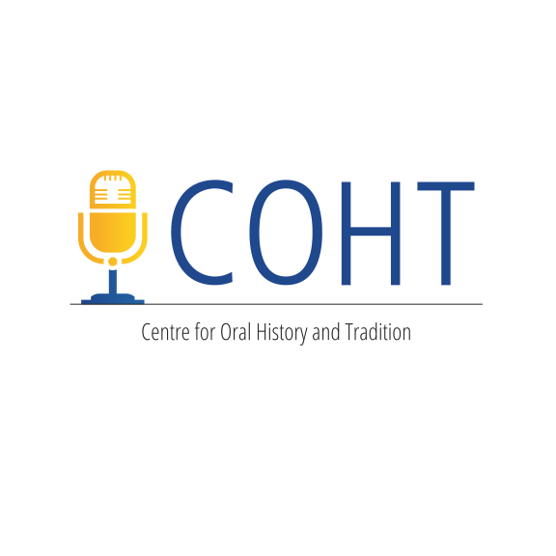
BEGINNER WORKSHOP AGENDA

- 9:30 – 9:45am: Introductions

- 9:45 – 10:15am: Brainstorming Your Project
Why do oral history? Who are you going to interview? What is the purpose of your project, including who is your audience? What is the project title?
- 10:15 – 10:45am: What is Oral History? Purpose, histories, types, and discussion of experience and examples. (Dr. Carly Adams, Dept. of Kinesiology and Physical Education, University of Lethbridge)

- 10:45 – 11:00am: Refreshment Break

- 11:00 – 11.45am: Building Your Project and Basic Practical Preparation Including general planning, organizational guidelines, ethics and consent, and follow-up procedures. (Dr. Jenna Bailey, COHT, University of Lethbridge)

- 11:45am – 12:30pm: Partner Practice Interviews (Be prepared to conduct a brief interview and be interviewed.)

- 12:30 – 1:00pm: Review of the Partner Practice Interviews

- 1:00 – 2:00pm: Lunch Break

- 2:00 – 2:30pm: Alternatives to Transcription & Working with Archives (Andrew Chernevych, Chief Archivist, Galt Museum & Archives)

- 2:30 – 3:00pm: Transcription Exercise

- 3:00 – 3:15pm: Refreshment Break

- 3:15 – 4:00pm: “How To Run A Successful Community Oral History Project.” Lessons Learned from the Coyote Flats Pioneer Village Oral History Project, Winner of the 2015 Governor General’s History Award for Excellence in Community Programming (Kimberly Lyall, Motivational Speaker and Project Manager)

- 4:00 – 4:20pm: Revising Your Oral History Project: Where Do You Go From Here?

- 4:20 – 4:30pm: Questions & Workshop Results & Feedback

