Academic Plan - 2022

University of Lethbridge Applied Studies
Academic Plan

As part of your Applied Studies course, you will need to develop an academic plan with your Academic Supervisor.

You can have 1 or more deliverables to your plan (ex. paper(s), presentation(s), project(s), or other academically appropriate deliverables). This plan comprises 70% of your total grade for the course. Please provide as much detail as possible.

After you submit this form, it will be sent to your Applied Studies Instructor to review, and then to your Academic Supervisor to give their approval.

Once approved you will receive an email with a PDF of the plan that you will need to upload into MyExperience. Contact your Applied Studies Instructor if you have any questions about this process.

Student's First Name
________________________________________________________________

Student’s Last Name
________________________________________________________________

Student’s University of Lethbridge Email
________________________________________________________________

Applied Studies Instructor
Stacey Gaudette-Sharp: s.gaudette@uleth.ca
Lukas Neamtu: lukas.neamtu@uleth.ca
Erin Kennett: erin.kennett@uleth.ca
- s.gaudette@uleth.ca
- lukas.neamtu@uleth.ca
- erin.kennett@uleth.ca

Faculty Supervisor’s Full Name
________________________________________________________________

Faculty Supervisor’s Email
________________________________________________________________

Additional supports/supervisors and their role in this plan (optional)
________________________________________________________________
________________________________________________________________
________________________________________________________________
________________________________________________________________
________________________________________________________________

Applied Studies Course Structure
Grading Breakdown
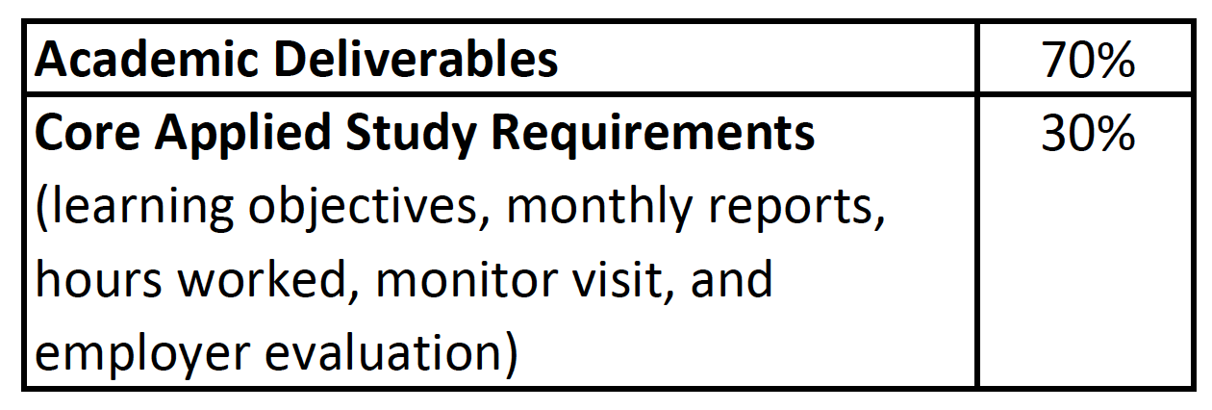
Applied Studies Rubric
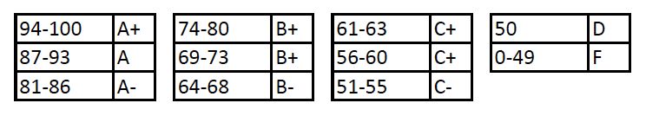

Academic Deliverables
Identify the deliverables that comprise 70% of your total grade for the course.

- Identify and describe each deliverable
- Assign weightings to them totaling 70%

Additional file provided by Faculty Supervisor (optional)
If your Academic Supervisor developed a plan for your academic deliverable(s), please attach it here.
Note: You will still need to provide the required information below.

Academic Deliverable #1
Provide a detailed description of the deliverable(s) that make up your course. Provide the expectations, deadlines, format, content, methods, and other requirements. Be as specific and clear as possible.
Examples can include:
- Paper
- Presentation
- Project
- Other academically appropriate deliverables

- Description (required) ________________________________________________
- If a paper: expected headings/topics, page/word limit, citation style ________________________________________________
- If a presentation: expected headings/topics, slide limit, speaking notes, ________________________________________________
- Working bibliography ________________________________________________
- Additional details/expectations or grading information ________________________________________________
- Deadline (mm/dd/yyyy) (required) ________________________________________________

Academic Deliverable #2 (optional)
- Description (required) ________________________________________________
- If a paper: expected headings/topics, page/word limit, citation style ________________________________________________
- If a presentation: expected headings/topics, slide limit, speaking notes, ________________________________________________
- Working bibliography ________________________________________________
- Additional details/expectations or grading information ________________________________________________
- Deadline (mm/dd/yyyy) (required) ________________________________________________

Academic Deliverable #3 (optional)
- Description (required) ________________________________________________
- If a paper: expected headings/topics, page/word limit, citation style ________________________________________________
- If a presentation: expected headings/topics, slide limit, speaking notes, ________________________________________________
- Working bibliography ________________________________________________
- Additional details/expectations or grading information ________________________________________________
- Deadline (mm/dd/yyyy) (required) ________________________________________________

Academic Deliverable #4 (optional)
- Description (required) ________________________________________________
- If a paper: expected headings/topics, page/word limit, citation style ________________________________________________
- If a presentation: expected headings/topics, slide limit, speaking notes, ________________________________________________
- Working bibliography ________________________________________________
- Additional details/expectations or grading information ________________________________________________
- Deadline (mm/dd/yyyy) (required) ________________________________________________

Weighting of Deliverables
Your value total must equal 70 to submit this form.
Academic Deliverable #1 : _______
Academic Deliverable #2 (optional) : _______
Academic Deliverable #3 (optional) : _______
Academic Deliverable #4 (optional) : _______
Total : ________

Academic Plan Reflection
Discuss the value of your deliverable(s) to your professional and academic development. Minimum 300 words.
________________________________________________________________
________________________________________________________________
________________________________________________________________

Student Signature

