Job/Position/Work Type: | Location of Work: | Date: Click here to enter a date.
Assessment completed by: |  | Reviewed/Revised:

Activity/Task  (List all tasks and activities of the job/work) | Description of  Hazard  Note: There may be more than one hazard associated with an activity or task. | Likelihood (L) | Severity (S) | Risk Total = (L*S) | Rating (High, Moderate, Low) | Hierarchy of Hazard Controls  (OHS Code 2009, Part 2 section 9)  Elimination/Substitution (E/S) if this not an option the following hierarchy of controls is to be followed:  - Engineering Controls (EC)  - Administrative Controls (AC)  - Personal Protective Equipment (PPE) | 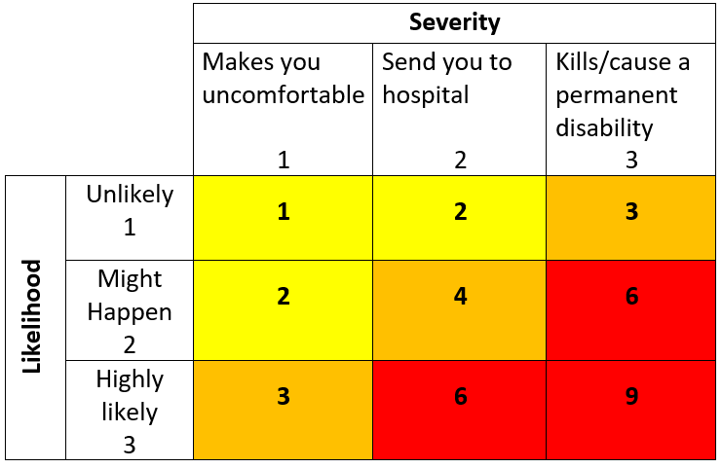  High Risk  Moderate Risk  Low Risk
Interacting with people | Psychological  Harassment/ Bullying  Workplace Violence  Sexual Assault |  |  |  |  | EC: Door locks  AC: Emergency Response Plan  AC: Working Alone Policy and procedures  AC: Wellness Manager/consultant – Homewood Health resources, Employee Assistance Program  AC: Violence and Harassment Policy  AC: Campus Security Services  AC: Workplace Campus Incident/Accident Report and Investigation Procedure  AC: Code of Conduct  AC: VTRA training
(When describing the controls to reduce the risk associated with each hazard the above hierarchy must be followed, with personal protective equipment as the last means of control)

By signing this form, you acknowledge that you understand the hazards and associated controls:

Supervisor’s Name Supervisor’s Signature

Worker Name | Signature | Date

