Job/Position/Work Type:  General Office Staff | Location of Work:  University of Lethbridge Campus | Date: Click here to enter a date.
Assessment completed by: |  | Reviewed/Revised:

Activity/Task  (List all tasks and activities of the job/work) | Description of  Hazard  Note: There may be more than one hazard associated with an activity or task. | Likelihood (L) | Severity (S) | Risk Total = (L*S) | Rating (High, Moderate, Low) | Hierarchy of Hazard Controls  (OHS Code 2009, Part 2 section 9)  Elimination/Substitution (E/S) if this not an option the following hierarchy of controls is to be followed:  - Engineering Controls (EC)  - Administrative Controls (AC)  - Personal Protective Equipment (PPE) | 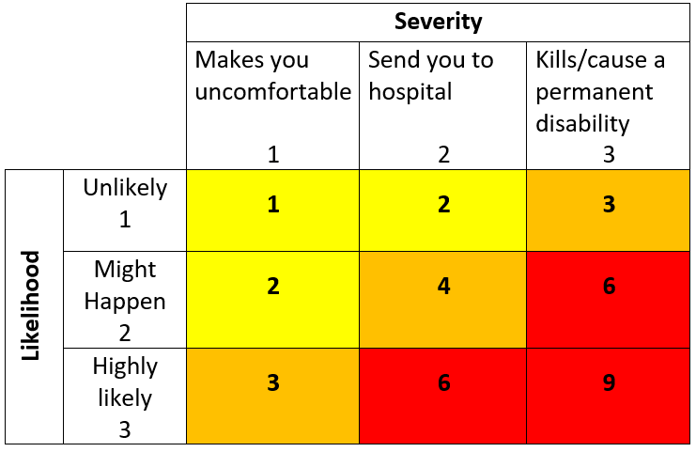  High Risk  Moderate Risk  Low Risk
Working at the computer | Repetitive strain injuries  Fatigue  Muscle stiffness,  Prolonged sitting Awkward postures  Eye strain |  |  |  |  | EC – Ergonomically designed equipment, use of lifting aids and carts  AC – Stretching, micro-breaks, work station ergonomic assessment, ergonomic resources, regular inspections, complete online Musculoskeletal Injury (MSI) and Move Safe training (Safety Services website).  PPE - Task and weather appropriate foot wear
Working with office equipment (e.g. phone, photocopier, fax machine, etc.) | Cuts/contusions  Burns  Electrical shock  Repetitive strain injuries  Fatigue  Awkward postures  Hazardous materials (e.g. toner, fire extinguisher) |  |  |  |  | E/S – Use of phone headset while multi-tasking  EC – Guards on equipment, toner is enclosed  AC – Tag out and repair/replace old unsafe equipment, maintain clutter free work area, use the right tool for the job, regular inspections, service and maintenance, review and follow safe work practices, procedures and safety bulletins, review Safety Data Sheet (SDS) when working with chemicals, fill filing cabinets from bottom to top, complete online Musculoskeletal Injury (MSI) and Move Safe training (Safety Services website). Request assistance when lifting heavy, awkward objects.
Filing | Repetitive strain/sprain  Fatigue  Pinning or crushing injuries  Prolonged standing Awkward postures |  |  |  |  | AC – Review Lifting and Filing practices and procedures, stretching, micro-breaks, complete online Musculoskeletal Injury (MSI) and Move Safe training (Safety Services website). Request assistance when lifting heavy, awkward objects.
Traversing the workspace, attending meetings, running errands, entering/exiting building | Struck by vehicle  Encounter with insects and wildlife (e.g. rattlesnakes, skunks, deer, coyote)  Poor lighting  Uneven, slippery ground causing physical injury (slips, trips and falls)  Damaged flooring  Cluttered walkways  Struck by vehicular traffic |  |  |  |  | E/S - Use indoor walkways, elevators  EC – Stair hand railings, parking lot lighting  AC - Regular inspections, step stools available, use of cord covers on cords crossing aisles/walk ways, good housekeeping and be aware of surroundings, signage at slippery/uneven areas, report slipping/tripping hazards and incidents to Facilities and Safety Services, report wildlife issues and emergencies to Security Services. Contact 911 as required for serious injuries. Avoid distracted walking and driving, yield to vehicle traffic, and use cross-walks and cross-walk signals when available.  PPE – Task and weather appropriate footwear and clothing
Using cords and electrical equipment | Electrocution  Shock  Burns  Slips, trips, falls |  |  |  |  | AC - No daisy chained power bars, no extension cords used as permanent wiring, CSA approved equipment only, regular inspections, service and maintenance, lock-out/tag-out damaged equipment, use cord covers on cords crossing isles and pathways.
Cleaning, maintenance or renovation activities  Activities causing air quality issues | Dusts  Fumes  Allergens  Asthma triggers  Exhaust emissions  Mold,  Headaches, illness  Eye irritation/damage |  |  |  |  | AC - Adhere to Safety Data Sheet (SDS) guidelines, regular custodial cleaning, appropriate equipment on hand, open communication with contractors and Facilities staff and/or University Contact overseeing renovations and/or maintenance, reporting air quality issues to Facilities Department and Safety Services.  PPE - nitrile or other appropriate gloves, respirator and eye protection (as required)
Dealing with staff and/or public. Staff or client consultations, meetings, events. | Physical Violence  Harassment  Stress  Fatigue |  |  |  |  | EC – Camera surveillance  AC – Review Harassment and Violence policy, VTRA training, Safe Walk, Working Alone procedures, familiarization with emergency procedures, communication device on hand to summon help, visitor management processes in place, healthy personal habits, employee assistance program, work-life balance.
Handling orders, pick up and deliveries of supplies and materials | Strains, sprains  Fatigue  Awkward postures  Repetitive strain injury  Improper lifting |  |  |  |  | EC – Use of carts and lifting devices, rolling shelving, guards on equipment  AC - Stretching micro-breaks, ergonomic resources, ask for help as needed, plan ahead, complete online Musculoskeletal Injury (MSI) and Move Safe training (Safety Services website). Good housekeeping practices  PPE – task and weather appropriate clothing and foot wear, gloves as required
Driving for Work | Collision  Wildlife on road  Fatigue  Mechanical problems  Poor road conditions  Violence |  |  |  |  | EC: mechanically sound vehicle, seat belt, air bag, locking doors  AC: cell phone, driver agreements, experienced driver, defensive driving, planned route, maps or GPS, working alone protocol, regular breaks, valid driver’s license, obey traffic laws, check weather ahead of time, leave early when possible, take regular breaks  PPE: task and weather appropriate clothing and footwear
Working Alone | Medical issue  Sudden illness  Fatigue,  Isolation  Physical violence  Harassment  Conflict |  |  |  |  | E/S: When possible, do not work alone  EC: Lock the door when possible  AC: Access to communication device, review policy/procedures, call in/check in, planned route, scheduling.
Working at heights | Slips, Trips and Falls  Falling objects  Interference with pedestrian traffic |  |  |  |  | AC - Follow ladder/step stool procedures, Fall Protection Plan (as required), pre-use ladder inspection, use within capacity, use the right ladder for the job, request assistance and use a spotter as required, cordon off area from public.
Building/ campus Emergency and/or Evacuation | Burns Smoke/chemical inhalation  Physical injury  Violence  Extreme weather conditions (i.e. blizzard, tornado)  Building collapse Infrastructure failure (e.g. damaged water line causing flooding)  Chemical Release  Blocked emergency exits |  |  |  |  | EC – Lock doors (if required)  AC - Review and follow emergency procedures, familiarize yourself with the area Campus Incident Response Team (CIRT) member, nearest exits, location of pull stations, fire extinguishers, Automated External Defibrillator (AED) and the nearest assembly point. Report to 911 (if required) and Security at (403)329-2345. Report blocked emergency exits.
(When describing the controls to reduce the risk associated with each hazard the above hierarchy must be followed, with personal protective equipment as the last means of control)

By signing this form, you acknowledge that you understand the hazards and associated controls:

Supervisor’s Name Supervisor’s Signature

Worker Name | Signature | Date

