Job/Position/Work Type:  Motor Vehicle Use for Work | Location of Work: | Date: Click here to enter a date.
Assessment completed by: |  | Reviewed/Revised:

Activity/Task  (List all tasks and activities of the job/work) | Description of  Hazard  Note: There may be more than one hazard associated with an activity or task. | Likelihood (L) | Severity (S) | Risk Total = (L*S) | Rating (High, Moderate, Low) | Hierarchy of Hazard Controls  (OHS Code 2009, Part 2 section 9)  Elimination/Substitution (E/S) if this not an option the following hierarchy of controls is to be followed:  - Engineering Controls (EC)  - Administrative Controls (AC)  - Personal Protective Equipment (PPE) | 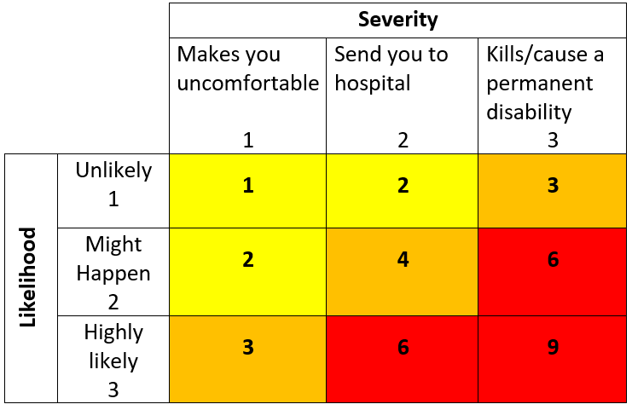  High Risk  Moderate Risk  Low Risk
Fueling | Fire/explosion  Toxic vapors/odors  Slips, trips, falls  Struck by vehicular traffic |  |  |  |  | AC – Review and follow safe work procedures, fire extinguisher on hand, no cell phone use during refueling.  PPE – Task and weather appropriate clothing and footwear
Driving and parking motor vehicle | Mechanical Failure  Collision with object, vehicle, pedestrian, wildlife  Sun/snow blindness  Poor road conditions  Stress/fatigue  Violence  In-vehicle distraction  Distracted driving |  |  |  |  | EC – Locking doors, seat belts  AC – Complete U of L Driver Agreement, cell phone for communication, vehicle inspections, valid driver’s license, motor vehicle insurance, follow traffic laws, schedule suitable amount of time to get to destination – drive defensively, take regular breaks, check weather/road reports prior to trip, If collision occurs, report to your supervisor and submit a Campus Safety Incident Report.  PPE – Task and weather appropriate clothing and footwear, sunglasses as required.
Working Alone | Isolation  Medical emergency  Illness  Violence  Fatigue |  |  |  |  | E/S – When possible, do no travel alone  AC – Review Working Alone Policy and procedures. Have a schedule and check-in plan, emergency contact list, take regular breaks as required  AC – Access to communication device (e.g. cell phone)
Loading/ unloading vehicle | Musculoskeletal injuries (e.g. strains, sprains)  Pinch points  Crushing injuries  Collision with pedestrian/traffic  Property damage  Slips, trips and falls |  |  |  |  | EC – Use of carts to transport material  AC – When lifting large/heavy/cumbersome items, request help and have spotter, use proper lifting techniques, complete Musculoskeletal Injury (MSI) online training on Safety Services website, use loading dock. If no loading dock or designated parking space, obtain approval for location and use safety cones and spotter  PPE – Task and weather appropriate clothing and footwear
(When describing the controls to reduce the risk associated with each hazard the above hierarchy must be followed, with personal protective equipment as the last means of control)

By signing this form, you acknowledge that you understand the hazards and associated controls:

Supervisor’s Name Supervisor’s Signature

Worker Name | Signature | Date

