Job/Position/Work Type:  General Equipment Repair | Location of Work:  U of L Campus | Date: Click here to enter a date.
Assessment completed by: |  | Reviewed/Revised:

Activity/Task  (List all tasks and activities of the job/work) | Description of  Hazard  Note: There may be more than one hazard associated with an activity or task. | Likelihood (L) | Severity (S) | Risk Total = (L*S) | Rating (High, Moderate, Low) | Hierarchy of Hazard Controls  (OHS Code 2009, Part 2 section 9)  Elimination/Substitution (E/S) if this not an option the following hierarchy of controls is to be followed:  - Engineering Controls (EC)  - Administrative Controls (AC)  - Personal Protective Equipment (PPE) | 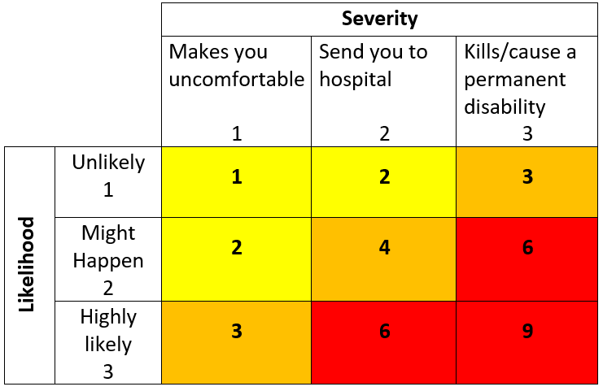  High Risk  Moderate Risk  Low Risk
General Equipment Repair | Contact injuries:  -entanglement,  -pinch points  -drawing-in,  -abrasions,  -cuts, punctures  -severing  -burns,  -electrical shock,  -electrocution  Fire  Slips, trips, falls  Excessive noise  Eye injury |  |  |  |  | E/S – Contract repair work to external service provider  EC – Physical barriers/guards on equipment used, energy source isolation using lock-out-tag-out procedures  AC – Follow safe work procedures on equipment repair and lock-out/tag-out procedures, authorized personnel in workshop/area only, competent trained personnel working on equipment, all workshop tools and equipment is regularly maintained and serviced, electrical cables and plugs regularly visually inspected for damage, defective equipment is reported and taken out-of-service until the repair has been effected, flammable substances kept in appropriate fire resistant cabinet, fire extinguisher and evacuation procedures in place.  PPE – CSA approved steel-toed footwear, hearing protection, eye protection, gloves
Working Alone | Isolation  Lack of communication  Medical Emergency  Injury/illness |  |  |  |  | E/S – Work in teams or with another individual  EC – Telephone, cell phone  AC – Fire extinguisher training current, working areas kept clear of obstructions and trailing cables, work area well lit, review Working Alone Policy
Manual material handling - lifting; moving heavy items | Musculoskeletal injuries  Slips, trips, falls |  |  |  |  | EC – Use of manual handling aids (e.g. carts, mechanical lifting devices, trolley)  AC – Training and proper lifting techniques used, ask for assistance when lifting large, bulky items, prior to difficult lifting, agree on a safe system of work and ensure clear path; spotters; “Move Safe” training
Working with/ around hazardous substances | Dermatitis  Skin sensitization  Irritating/toxic vapors  Dust/vapor inhalation  Eye injury  Chronic exposure (irritation, allergic reaction) |  |  |  |  | E/S – Substitute a less toxic product if possible  EC – Ventilation  AC – WHMIS training current, Safety Data Sheet (SDS)/ Materials Safety Data Sheet (MSDS) is available for reference, all containers used for storage of hazardous and non-hazardous substances are labelled indicating their contents.  PPE – Eye protection, fit-tested respirator, gloves (as required).
Working at heights (e.g. ladder) | Fall from height  Struck by falling objects |  |  |  |  | E/S – Move work to ground level when possible  AC – Safe work procedures/training on working at heights (e.g. ladders/lifts), Fall Protection Plan (as required), formal documented inspection of ladders carried out and records kept on file, visual inspection of lift/ladder for damage by user prior to use, separate work area (e.g. scissor gates, caution tape) to prevent pedestrian traffic  PPE – Travel restraint, fall arrest equipment, hard hat (as required)
Welding/  Soldering | Burns  Exposure to toxic fumes/gases  Eye injury  Property damage  Fire/explosion  Excessive noise  Radiation  Musculoskeletal injuries |  |  |  |  | E/S – Contract work to external service provider  EC – Ventilation, shielding/welding screens  AC – Safe work procedures/training, regular equipment inspections, hot work permit/fire watch (as required), fire extinguisher and evacuation procedures, proper lifting, minimize vibration, keeping work at comfortable height, regular work breaks, work performed in areas free of combustible materials, cylinders stored/chained in upright position, level of noise measured, and suitable hearing protection used.  PPE – Eye/face protection, protective clothing, hearing protection, fit-tested respirator, gloves (as required)
(When describing the controls to reduce the risk associated with each hazard the above hierarchy must be followed, with personal protective equipment as the last means of control)

By signing this form, you acknowledge that you understand the hazards and associated controls:

Supervisor’s Name Supervisor’s Signature

Worker Name | Signature | Date

