
DON’T WEAR PROTECTIVE GLOVES
OUTSIDE THE RESEARCH LABORATORY

Gloves may become contaminated during research procedures
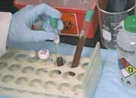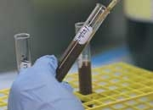
Wearing gloves into public areas may lead to cross-contamination
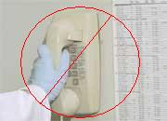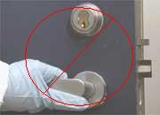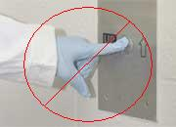
As a routine safety precaution, gloves must be REMOVED prior to entering any unrestricted area such as corridors, elevators, restrooms, public dining areas, and offices.
Please be considerate and protect both the safety and peace of mind of others.

Transporting Specimens
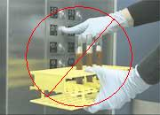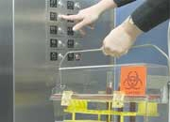
When research samples are transported from one location to another, secondary containers should be used, eliminating the need for gloves. Alternatively, use a gloved hand to carry the container and an ungloved hand to open doors. Carry extra gloves with you.

Contact Safety Services
safety.services@uleth.ca
for further information.

