Job/Position/Work Type:  Tipi Raising | Location of Work: | Date: Click here to enter a date.
Assessment completed by: |  | Reviewed/Revised:

Activity/Task  (List all tasks and activities of the job/work) | Description of  Hazard  Note: There may be more than one hazard associated with an activity or task. | Likelihood (L) | Severity (S) | Risk Total = (L*S) | Rating (High, Moderate, Low) | Hierarchy of Hazard Controls  (OHS Code 2009, Part 2 section 9)  Elimination/Substitution (E/S) if this not an option the following hierarchy of controls is to be followed:  - Engineering Controls (EC)  - Administrative Controls (AC)  - Personal Protective Equipment (PPE) | 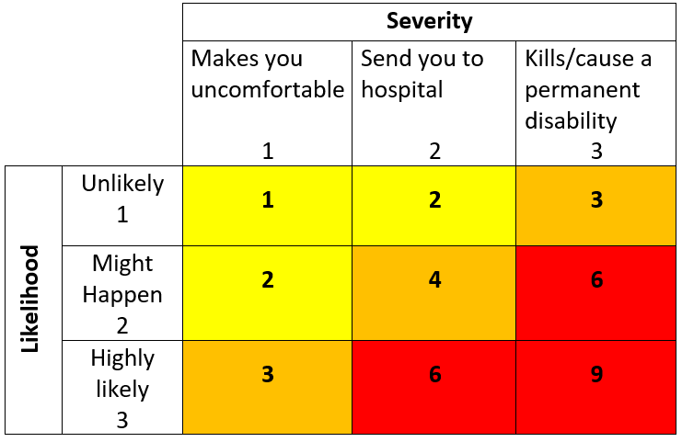  High Risk  Moderate Risk  Low Risk
Working Alone | -Lack of communication  -Isolation  -Medical Emergency  -Injury/illness  -Violence |  |  |  |  | EC: telephone; cell phone  AC: training, organizing and planning work, rotation of workers, UofL working alone procedure and login system; check in/out procedure, work as a team
Transporting Tipi to/from location | -Injury to pedestrians  -Heavy/awkward lifting causing strains, sprains |  |  |  |  | EC: Use carts or dollies if possible  AC: training, organizing and planning work, rotation of workers, use of spotter(s), schedule move during quite time of day  PPE: Gloves and closed-toed shoes, as required
Erect/take down Tipi  Indoor Set-up | -blocking egress route  -damage/block sprinklers  -damage light fixtures |  |  |  |  | EC: barricades/scissor gates  AC: Competent workers, do not block egress routes, walk-ways or exit doors, follow safe work procedures, look and take note where sprinkler heads are and maintain a distance of at least 18” below sprinkler head, use of spotters during set-up and take down,  PPE: Gloves and closed-toed shoes, as required
Erect/take down Tipi  Outdoor Set-up | -utility line strike  -high winds (above 30km/hr)  -rattlesnake bites  -trips/falls - gopher holes & uneven ground |  |  |  |  | EC: barricades/scissor gates  AC: Request line locates when erecting outdoors, competent workers, do not block egress routes, paths or sidewalks, safe work procedures, watch your step and be aware of your surroundings, for emergencies and first aid contact Security Services at 403-329-2345 and/or 911 if required, use of spotters during set-up and take down, monitor weather forecast for inclement weather and disassemble tipi when required.  PPE: Gloves and closed-toed shoes, as required
Erect/take down Tipi  Indoor & Outdoor Set-up | -damage to tipi  -pinch points  -heavy/awkward lifting  -falls from heights  -rope burns  -injury to pedestrians |  |  |  |  | EC: barricades/scissor gates  AC: Competent workers, review and follow safe work procedures, use proper lifting techniques, watch your step and be aware of your surroundings, for emergencies and/or first aid contact Security Services at 403-329-2345 and/or 911 if required, when working from heights of 3 meters or more, have a Fall Protection Plan in place, use of spotters during set-up and take down, monitor weather forecast for inclement weather.  PPE: Gloves and closed-toed shoes, as required
Building/ campus Emergency Evacuation | Burns, smoke inhalation resulting from Fire  Active Shooter (Violence)  Inclement weather (i.e. tornado)  Building collapse  Chemical Release |  |  |  |  | AC - Review and follow emergency procedures, familiarize yourself with the location of nearest exits, fire extinguishers and assembly point, immediately contact Security at (403)329-2345 and/or 911 (as required) to report emergencies.
(When describing the controls to reduce the risk associated with each hazard the above hierarchy must be followed, with personal protective equipment as the last means of control)

By signing this form, you acknowledge that you understand the hazards and associated controls:

Supervisor’s Name Supervisor’s Signature

Worker Name | Signature | Date

