Job/Position/Work Type:  Smudge Ceremony | Location of Work: | Date: Click here to enter a date.
Assessment completed by: |  | Reviewed/Revised:

Activity/Task  (List all tasks and activities of the job/work) | Description of  Hazard  Note: There may be more than one hazard associated with an activity or task. | Likelihood (L) | Severity (S) | Risk Total = (L*S) | Rating (High, Med, Low) | Hierarchy of Hazard Controls  (OHS Code 2009, Part 2 section 9)  Elimination/Substitution (E/S) if this not an option the following hierarchy of controls is to be followed:  - Engineering Controls (EC)  - Administrative Controls (AC)  - Personal Protective Equipment (PPE) | 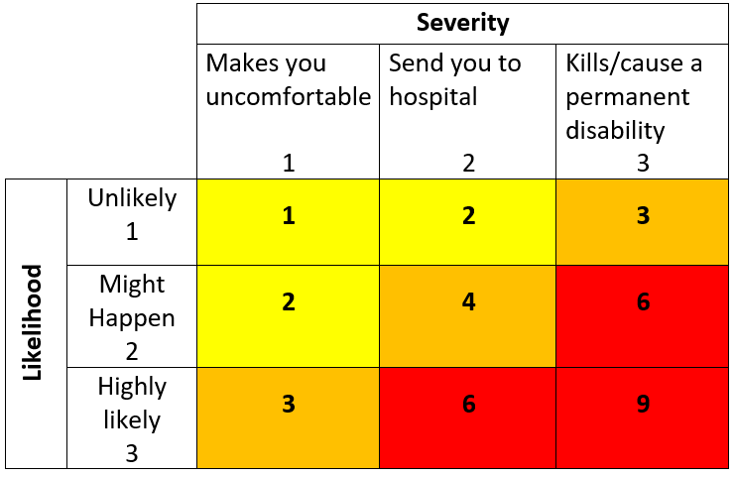  High Risk  Moderate Risk  Low Risk
Smudge – Burning of Sweetgrass  Low/ minimal amount of fragrant smoke in room that activity will be conducted. NOTE: Similar to burning of incense. Smell may linger for 15-30 minutes after “Smudge” is conducted. | Smoke  Allergies  Skin Burns  Fire/ Property Damage  False Fire Alarms |  |  |  |  | EC – Ventilation. Facilities is made aware of the event and requirement to supply adequate ventilation to the space during and after the event. No fire alarms appear visible in direct space. If fire alarm systems are confirmed, request Utilities to have them taken off-line for duration of ceremony and until smoke dissipates from area.  AC: Experienced Elder, trained/orientated event coordinator(s), follow Standard Operating Procedure: ‘Smudging and Pipe Offering Procedures for University of Lethbridge Designated Areas’  AC – Ensure event organizers are aware of nearest fire extinguisher and first aid kit location and knowledgeable of its use if required. Call 911 and Security Services (403)329-2345 in the event of a emergency (e.g. serious medical emergency, fire).  AC – Building evacuation procedures and assembly point reviewed with event coordinators.
Building/ campus Emergency Evacuation | Burns, smoke inhalation  Violence (i.e. Active Shooter)  Inclement weather (i.e. tornado)  Building collapse  Chemical Release |  |  |  |  | AC - Review and follow emergency procedures, familiarize yourself with the nearest exits, where fire extinguishers are located and location of the nearest assembly point, immediately contact Security at (403)329-2345 to report emergencies.
(When describing the controls to reduce the risk associated with each hazard the above hierarchy must be followed, with personal protective equipment as the last means of control)

By signing this form, you acknowledge that you understand the hazards and associated controls:

Supervisor’s Name Supervisor’s Signature

Worker Name | Signature | Date

