Job/Position/Work Type:  Public Shredding Event | Location of Work: | Date: Click here to enter a date.
Assessment completed by: |  | Reviewed/Revised:

Activity/Task  (List all tasks and activities of the job/work) | Description of  Hazard  Note: There may be more than one hazard associated with an activity or task. | Likelihood (L) | Severity (S) | Risk Total = (L*S) | Rating (High, Moderate, Low) | Hierarchy of Hazard Controls  (OHS Code 2009, Part 2 section 9)  Elimination/Substitution (E/S) if this not an option the following hierarchy of controls is to be followed:  - Engineering Controls (EC)  - Administrative Controls (AC)  - Personal Protective Equipment (PPE) | 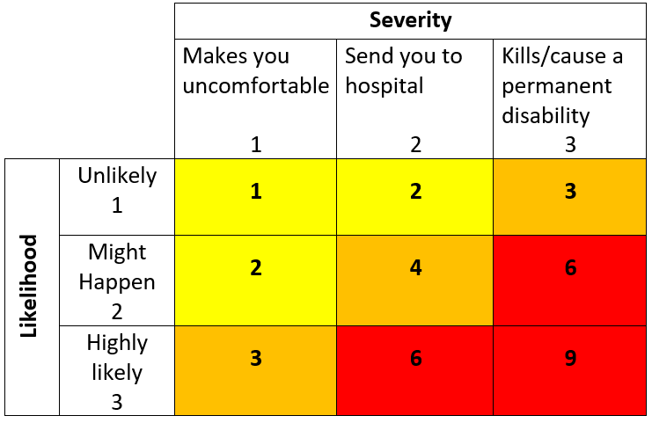  High Risk  Moderate Risk  Low Risk
Use of one 10’ x 10’ pop-up canopy tent  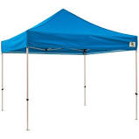  Tent set up on grass next to sidewalk. | Pinched fingers while setting up/tearing down  Extreme wind/weather  Equipment failure  Dropping anchor weights |  |  |  |  | E/S: Facilities staff will set up and tear down tent according to manufacturer’s instructions.  EC: Weights will be placed over each leg of tent to ensure that it does not move with the wind.  AC: Should tent fail, Facilities will be contacted to immediately remove it from the site (provided it is safe to do so), contact Security for first aid services, tent will be removed in the event of extreme wind gusts (over 30 km/hour), heavy rain or snow.
Setting up table & sandwich boards | Pinched fingers while setting up/tearing down  Physical injuries (cuts, sprains, strain, broken bones) |  |  |  |  | AC: Carts will be used to move table, chairs, and sandwich boards to/from their location, two people will set up table, and tables will be removed in the event of extreme wind gusts (over 30 km/hour), heavy rain or snow.  PPE: Closed toed shoes, gloves as required.
Being outdoors for extended periods of time | Physical injuries (cuts, sprains, strain, broken bones)  Heavy lifting  Repetitive lifting |  |  |  |  | EC: Use tent to provide shelter from the elements.  AC: Site leads will watch for signs that weather/insects/allergic reactions are impacting staff and will notify Security/First Aid trained staff/911 if needed, cell phone will be on site and staff can seek shelter under tent from sun, bring bottled water and dress appropriately for the weather, take regular breaks indoors if weather is poor.  PPE: Sunscreen and/or insect repellant as required
Moving & lifting materials, including boxes and electronics, out of vehicles and into shredding or recycling bins | Physical injuries (cuts, sprains, strain, broken bones)  Heavy lifting  Repetitive lifting |  |  |  |  | EC: Use cart to move heavy loads to shredding bins  AC: Review manual materials handling practices and tips before lifting, use materials handling practices, including getting assistance with a heavy or awkward load (refer to posters on site), watch for and remove items in material to be shredded that could potentially cause harm or damage to equipment (sharp objects, etc.)  PPE: Closed toed shoes, gloves as required.
Unloading materials from vehicles | Tripping hazards (sidewalk)  Traffic |  |  |  |  | AC: Watch for oncoming traffic and wait for it to pass/stop before entering roadway, sandwich board will tell participants where to stop their vehicles for unloading  PPE: Wear reflective vest
Observing Shredding | Excessive noise |  |  |  |  | E/S: External Services provider (contractor) who has been orientated to the University of Lethbridge prior to starting work will be operating the shredding truck.  AC: Maintain suitable distance from shredding truck while shredding is being done.  PPE: Wear ear plugs while shredding is being done.
Moving and lifting shredding bins | Physical injuries (cuts, sprains, strain, broken bones)  Heavy lifting  Repetitive lifting |  |  |  |  | E/S: Lift on truck lifts and empties bins into shredder  EC: Wheels on shredding bins allow them to be moved without lifting  AC: Workers will adhere to Lethbridge Mobile Shredding safe work practices for handling shredding bins and stay hydrated.  PPE: Wear steel-toed boots, dress appropriately for the weather,
Operating shredding truck | Loud noise  Inclement Weather  Pedestrian traffic |  |  |  |  | AC: Lethbridge Mobile Shredding workers must be trained in operation of the shredding truck, maintain distance from truck when possible, ensure that sidewalk is not blocked for passing pedestrians.  PPE: Wear ear plugs and dress appropriately for the weather. Use sunscreen and insect repellant as required.
Building/ campus Emergency Evacuation | Burns, smoke inhalation  Active Shooter  Inclement weather (i.e. tornado)  Building collapse  Chemical Release |  |  |  |  | AC - Review and follow emergency procedures, familiarize yourself with the nearest exits, where fire extinguishers are located and location of the nearest assembly point, immediately contact Security at (403)329-2345 to report emergencies.
(When describing the controls to reduce the risk associated with each hazard the above hierarchy must be followed, with personal protective equipment as the last means of control)

By signing this form, you acknowledge that you understand the hazards and associated controls:

Supervisor’s Name Supervisor’s Signature

Worker Name | Signature | Date

