Job/Position/Work Type:  Outdoor Events | Location of Event: | Date: 01/11/2019
Assessment completed by: |  | Reviewed/Revised:

Activity/Task  (List all tasks and activities of the job/work) | Description of  Hazard  Note: There may be more than one hazard associated with an activity or task. | Likelihood (L) | Severity (S) | Risk Total = (L*S) | Rating (High, Moderate, Low) | Hierarchy of Hazard Controls  (OHS Code 2009, Part 2 section 9)  Elimination/Substitution (E/S) if this not an option the following hierarchy of controls is to be followed:  - Engineering Controls (EC)  - Administrative Controls (AC)  - Personal Protective Equipment (PPE) | 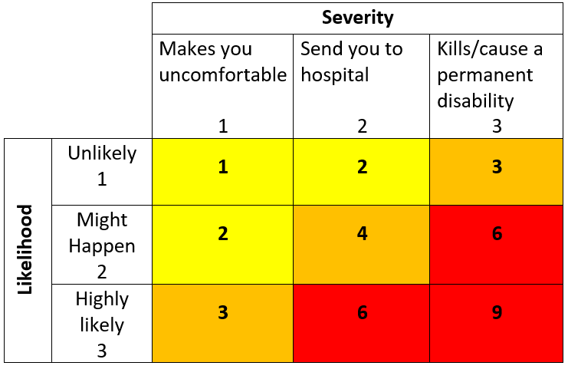  High Risk  Moderate Risk  Low Risk
Guests attending events  Uneven ground  Uneven pathways  Electrical cords  Hoses  Etc. | slips, trips falls  body injuries (e.g. strains, sprains, bruising, breaks, concussions) |  |  |  |  | EC: Cart service available for guest transportation  AC: Site Orientation provided to booking party and notification provided in booking package  AC: Handicap parking stalls, traffic control and handicap access  AC: Vehicles kept off the main driveway  AC: Hoses/cords put away. If cords required, they will be fastened to the ground with duct tape or cord covers  AC: First Aid Station and Designated First Aider  AC: Contact 911 when required. Campus Security Services trained in First Aid response (403-329-2345  AC: Inspection of grounds prior to the event.  PPE: Suitable shoes recommended for traversing uneven ground
Extreme weather conditions  Hot temperatures  Cold temperatures  High winds  Tornado  Thunder storm | sunburn  heat stroke/heat stress  chills  struck by lightning  struck by flying debris |  |  |  |  | AC: Notification addressing weather provided to booking party in booking package  AC: Guests notified to wear suitable clothing and footwear to suit environment and all weather conditions  AC: All buildings are open and available to guests to escape from extreme weather  AC: Water stations provided for guests  AC: First Aid Station and Designated First Aiders  AC: Securement of tent to withstand high winds  AC: Emergency Plan/Procedures developed and reviewed  PPE: Sunscreen, clothing suitable for environment
Insects on property  Mosquitoes  Bees  Wasps  Etc. | Insect bites  Allergies |  |  |  |  | AC: Emergency Plan/Procedures developed and reviewed  AC: Notification provided to booking party in booking package  AC: First Aid Station and Designated First Aiders  AC: Contact 911 when required. Campus Security Services trained in First Aid response (403-329-2345)  PPE: bug spray
Unruly/inebriated guests, large crowds | Violence  Illness  Injury |  |  |  |  | AC: Alcohol consumed in designated areas only.  AC: Bartenders monitoring guests throughout event  AC: Bartenders and caterers have Coutts Centre Emergency Contact List and orientated to emergency procedures  AC: First Aid Station provided in Washroom Building  AC: Attendees not to exceed maximum occupancy  AC: Emergency Plan/Procedures developed and reviewed
Wildlife may be on property | unpredictable behavior  Bites, kicks, sprays, scratches |  |  |  |  | AC: Notification provided to booking party in booking package and guests by emcee to report and respect wildlife – keep your distance  AC: Emergency Plan/Procedures developed and reviewed  AC: Bartenders and caterers have Coutts Centre Emergency Contact List and orientated to emergency procedures.
Property Evacuation | Fire, tornado, high winds, violence, etc. |  |  |  |  | AC: Evacuation information provided to booking party in booking package  AC: Smoking only in designated areas  AC: Fire extinguisher located near event  AC: P.A. System for communication  AC: All buildings are open and available to guests to escape from extreme weather  AC: Emergency Plan/Procedures developed and reviewed  AC: Designated assembly/muster point socialized with booking party and guests  AC: Bartenders and caterers have Coutts Centre Emergency Contact List, monitor weather reports and are orientated to emergency procedures.
Responding to medical emergencies | Heart attack, stroke, injuries, illness, etc. |  |  |  |  | AC: Emergency information provided to booking party and guests  AC: AED/First Aid Station located in washroom building  AC: Designated Assembly/Muster Point  AC: Bartenders and caterers provided with Coutts Centre Emergency Contact List and are orientated to emergency plan/procedures
Working Alone | Isolation  Medical emergency  Violence |  |  |  |  | E/S: Work in pairs  EC: If possible, lock door  AC: Working alone policy and procedures
(When describing the controls to reduce the risk associated with each hazard the above hierarchy must be followed, with personal protective equipment as the last means of control)

By signing this form, you acknowledge that you understand the hazards and associated controls:

Supervisor Name: __________________ Supervisor Signature: ____________________

Worker Name | Signature | Date

