Job/Position/Work Type:  Indoor Event Set-up  Tables/Chairs/Display | Location of Work: | Date: Click here to enter a date.
Assessment completed by: |  | Reviewed/Revised:

Activity/Task  (List all tasks and activities of the job/work) | Description of  Hazard  Note: There may be more than one hazard associated with an activity or task. | Likelihood (L) | Severity (S) | Risk Total = (L*S) | Rating (High, Moderate, Low) | Hierarchy of Hazard Controls  (OHS Code 2009, Part 2 section 9)  Elimination/Substitution (E/S) if this not an option the following hierarchy of controls is to be followed:  - Engineering Controls (EC)  - Administrative Controls (AC)  - Personal Protective Equipment (PPE) | 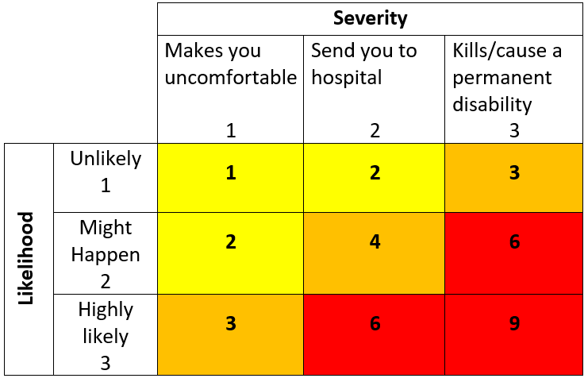  High Risk  Moderate Risk  Low Risk
Booth fair/Display Table Attendee | Musculoskeletal injuries due to static body position, prolonged sedentary work, repetitive strain injuries;  Fatigue |  |  |  |  | EC: Use of anti-fatigue mats, ensure workstations are designed appropriately to ease stress on physical health  AC: Attendees are limited to 1 to 1.5 hours; chairs provided, rotating workers, adjust workstation to fit individual, shift positioning or take short breaks on a regular basis (e.g. standing, sitting, walking, and stretching), stay hydrated.
Food & Beverage  service | Spill/slip hazard;  Burns |  |  |  |  | EC: Have clothes/spill absorption mats nearby; position service table out of main line of pedestrian traffic; first aid kit located near elevator.  AC: Notify Caretaking (403.329.2602) and/or Security Services (403.329.2345); use of approved U of L caterer; appropriate alcohol licensing and approvals.
Use of extension cords | Slips, trips, falls;  Shock, electrocution |  |  |  |  | AC: Any cables/cords will be taped down using gaffer tape to mitigate tripping hazard; cords will be inspected and in good condition; no daisy chaining of extension cords.
Lifting, moving materials, setting up display | Musculoskeletal injuries;  Collision with pedestrian traffic;  Falling objects |  |  |  |  | EC: Use of carts and dollies to move heavy/awkward loads  AC: Ask for assistance, use of spotter, use of proper lifting techniques, MSI online training https://www.uleth.ca/risk-and-safety-services/musculoskeletal-injury-msi-program-manual-material-handling  PPE: Closed-toed shoes, gloves as required
Public interaction | Aggressive/unruly behavior from visitors;  Bodily injury (physical violence);  Work-related stress;  Physical/mental harassment |  |  |  |  | AC: staff on-site to monitor, encourage pedestrian flow, and access points to offices, labs and elevator are not blocked; notify Security Services (403.329.2345) or 911 (in extreme emergency); when possible, work in teams of no less than two; Orientation/training; have access to a device for communication (e.g. radio, phone); take regular breaks, stay hydrated; signage indicating activity upon approach
Building evacuation | Blocking egress walkways/doors, fire extinguishers, pull stations, visual alarms or electrical panels;  Bodily injury;  Burns;  Toxic inhalation;  Structural collapse |  |  |  |  | AC: staff on-site to monitor, encourage pedestrian flow, and monitor egress routes to ensure they are not blocked; notify Security Services (403.329.2345) or 911 (in extreme emergency); enact institutional evacuation procedure; review and follow Emergency Response Plan; call 911 as required and notify Campus Security Services at 403-329-2345. Orientation provided to event participants on location of emergency exits, nearest Assembly Point(s), fire extinguisher and first aid station; signage indicating activity upon approach  PPE: Campus Incident Response Team (CIRT) to wear high visibility vests
Working Alone | Lack of communication;  Isolation;  Medical emergency;  Sudden illness;  Physical/mental harassment and/or violence |  |  |  |  | E/S: Work in teams of no less than two, avoid working alone when doing high risk activities (e.g. working at heights, in confined spaces, with electricity, with hazardous substances/materials, with hazardous equipment, or where there is a potential for violence)  AC: Review and follow Working Alone policy and procedures. Establish a check-in procedure; have access to communication device (e.g. phone, radio)
(When describing the controls to reduce the risk associated with each hazard the above hierarchy must be followed, with personal protective equipment as the last means of control)

By signing this form, you acknowledge that you understand the hazards and associated controls:

Supervisor’s Name: Supervisor’s Signature:

Worker Name | Signature | Date

