Job/Position/Work Type:  Service Provider/Contractor – Construction | Location of Work: | Date: Click here to enter a date.
Assessment completed by: |  | Reviewed/Revised:

Activity/Task  (List all tasks and activities of the job/work) | Description of  Hazard  Note: There may be more than one hazard associated with an activity or task. | Likelihood (L) | Severity (S) | Risk Total = (L*S) | Rating (High, Moderate, Low) | Hierarchy of Hazard Controls  (OHS Code 2009, Part 2 section 9)  Elimination/Substitution (E/S) if this not an option the following hierarchy of controls is to be followed:  - Engineering Controls (EC)  - Administrative Controls (AC)  - Personal Protective Equipment (PPE) | 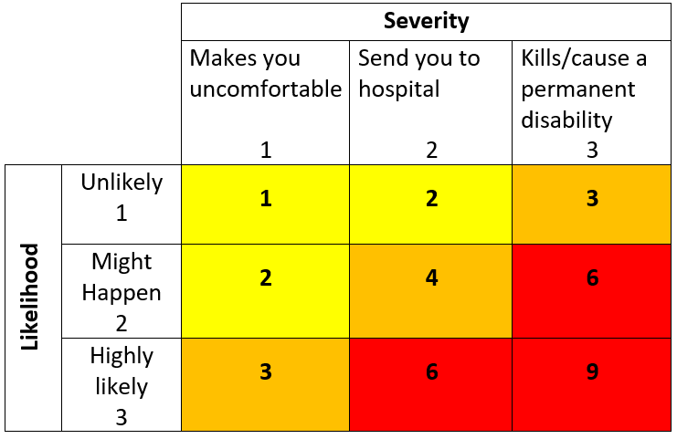  High Risk  Moderate Risk  Low Risk
Parking, unloading, transporting, loading materials at and through the University | Collision with vehicular and/or  pedestrian traffic (bodily injuries, property damage)  Musculoskeletal Injuries (strains, sprains, etc.) |  |  |  |  | EC – Use of carts  AC – Buddy system for lifting heavy items, use proper lifting practices, spotter  AC – Unload/Load at loading dock when possible.  AC – When no loading dock available – use approved location, date and time. Use of safety cones and spotter (Absolutely no parking on Student Union/Library sidewalk or south patio)  AC – Delineate work area with safety cones, scissor gates, fencing, etc.  PPE – gloves, closed toed shoes, CSA approved footwear when required
Set-up and take down of work area | Musculoskeletal Injuries  Slips, trips, falls  Fire hazards (burns, smoke inhalation, death)  Electrical hazards (shocks, burns, electrocution, death) |  |  |  |  | EC - CSA approved extension cords, power bars  AC – Use buddy system for lifting heavy items, use proper lifting practices, use spotter  AC – Do not block fire doors, aisles, pathways, exit routes  AC – If fire door is required to be propped open, it must be supervised. Close door when work complete.  AC – Proper use of extension cords/power bars – no daisy-chaining permitted, cord covers over cords in ailes and walkways.
Use of ladders | Slips, trips, falls  Awkward body position (e.g. sprains, strains, etc.)  Items falling from height  Ladder falling |  |  |  |  | AC: Orientation/training  AC: Use the right ladder for the job, pre-use inspection, review and follow safe work practices and procedures, Fall Protection Plan in place when at heights of working 3 meters or more  AC - Have a spotter to protect the person on the ladder as well as others from entering the work space  PPE: closed toe shoes
Dealing with the public | Work related stress  Fatigue  Physical violence or abuse |  |  |  |  | AC: When possible, work in teams of no less than two  AC: Orientation/training  AC: Have access to a phone for communication  AC: Take regular breaks, stay hydrated.  AC: Report suspicious activity to Campus Security Services at 403-329-2345
Working Alone | Lack of communication  Isolation  Medical emergency  Sudden illness  Physical violence |  |  |  |  | E/S: Work in teams of no less than two, avoid working alone when doing high risk activities (e.g. working at heights, in confined spaces, with electricity with hazardous substances/materials, with hazardous equipment, or where there is a potential for violence)  AC: Review and follow Working Alone policy and procedures. Establish a check-in procedure.  AC: Have access to phone for communication
Working with power tools and/or Equipment | Noise  Collision with pedestrian and/or other traffic |  |  |  |  | EC – Guards on equipment  AC – Inspections, training  AC – Delineate work area with safety cones, scissor gates, fencing, etc.  AC – Use of trained flagger (if required)  AC – Notifications to shareholders/Notice Board  AC – Scheduling of work  AC – Noise assessment  PPE – Hearing protection, CSA approved footwear, eye protection, hard hat
Ground Disturbance | Utility Line Strike  Fire/explosion causing burns, death  Crushing/cave-in  Asphyxiation  Property damage |  |  |  |  | AC – Ensure current line locates have been completed and marked  AC – Orientation, training, certification, competent workers  AC – Hand expose buried utilities in conflict with a ground disturbance before using mechanical excavation equipment within the hand expose zone. Mechanized excavation is not to be resumed until the buried facilities have been exposed to sight.  AC – Site signage  AC – Safe Work Procedures, Codes of Practice (e.g. Confined Space, Fall Protection, Ground Disturbance) Orientation, Training  PPE – CSA approved footwear, hard hat, high visibility vest, eye protection, hearing protection
Utility Tie-ins | Property damage  Shock, Electrocution Death  Bodily injury |  |  |  |  | AC – Notifications to appropriate personnel, scheduling  AC – Lock-out/Tag-out, safe work procedures,  AC – Training/orientation/certification  PPE – CSA approved footwear, hard hat, eye protection, hearing protection, gloves
Working At Heights | Slips, trips falls  Falling items |  |  |  |  | AC – Roof Access Procedure  AC – Fall protection plan, procedures, orientation, training, certification  AC – Delineate work area with safety cones, scissor gates, fencing, spotter, etc.  AC – Site signage  PPE – Fall arrest equipment
Hot Work (e.g. welding, grinding) | Fire (property damage)  Burns  Eye damage  Toxic fume inhalation |  |  |  |  | AC – Orientation, training, Hot Work Permit and fire watch  AC – Safe Work Procedures  PPE – CSA approved footwear, eye/face protection, gloves
Working with Chemicals | Burns  Eye damage  Absorption  Toxic Inhalation |  |  |  |  | E/S – Use a less toxic chemical  AC – Orientation, training (e.g. WHMIS)  AC – Safety Data Sheet (SDS) accessible  AC – Proper ventilation  PPE – Fit-tested respirator, eye/face protection, long sleeved shirts/pants, closed-toed shoes
Building Evacuation or Emergency | Bodily Injury (e.g. Violence)  Burns  Toxic Inhalation  Structural collapse |  |  |  |  | AC: Review and follow Emergency Response Plan. Call 911 as required and notify Campus Security Services at 403-329-2345. Orientation provided on location of emergency exits, nearest Assembly Point(s), emergency eyewash, emergency shower, first aid station and nearest fire extinguisher.
(When describing the controls to reduce the risk associated with each hazard the above hierarchy must be followed, with personal protective equipment as the last means of control)

By signing this form, you acknowledge that you understand the hazards and associated controls:

Supervisor’s Name Supervisor’s Signature

Worker Name | Signature | Date

