Job/Position/Work Type:  Teacher/Instructor - Classroom | Location of Work:  Classroom | Date: Click here to enter a date.
Assessment completed by: |  | Reviewed/Revised:

Activity/Task  (List all tasks and activities of the job/work) | Description of  Hazard  Note: There may be more than one hazard associated with an activity or task. | Likelihood (L) | Severity (S) | Risk Total = (L*S) | Rating (High, Moderate, Low) | Hierarchy of Hazard Controls  (OHS Code 2009, Part 2 section 9)  Elimination/Substitution (E/S) if this not an option the following hierarchy of controls is to be followed:  - Engineering Controls (EC)  - Administrative Controls (AC)  - Personal Protective Equipment (PPE) | 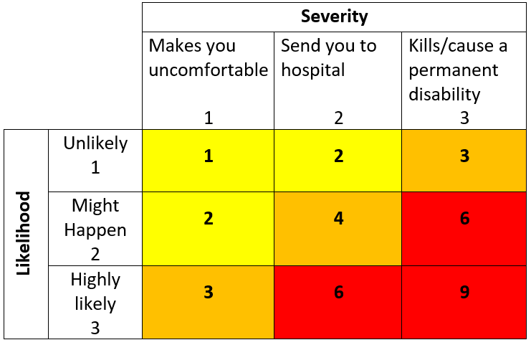  High Risk  Moderate Risk  Low Risk
Working Alone | Isolation  Medical emergency  Sudden illness  Workplace Harassment Workplace Violence |  |  |  |  | E/S: When possible, do not work alone  EC: Lock the door when possible and if required  AC: Access to communication device, review policy/procedures, call in/check in, planned route, scheduling.
Instructing/ teaching/ presenting to a class | Workplace Harassment Workplace Violence  Conflict situations |  |  |  |  | EC – Camera surveillance  AC – Review Harassment and Violence policy, VTRA training, Safe Walk, Working Alone procedures, familiarization with emergency procedures, communication device on hand to summon help, visitor management processes in place,
 | Disease transmission |  |  |  |  | AC – Follow proper hand washing practices, sneeze into your arm, disinfect classroom materials and surfaces, and do not share personal items.
 | Work-related stress  Fatigue |  |  |  |  | AC – Take regular breaks, healthy personal habits, employee assistance program, work-life balance
 | Ergonomic issues, Awkward postures  Prolonged standing |  |  |  |  | AC –Stretching, micro-breaks, complete online Musculoskeletal Injury (MSI) and Move Safe training (Safety Services website). Request assistance when lifting heavy, awkward objects.
 | Slips, trips, falls |  |  |  |  | AC - Regular inspections, use of cord covers on cords crossing aisles/walk ways, good housekeeping and be aware of surroundings, signage at slippery/uneven areas, report slipping/tripping hazards and incidents to Facilities and Safety Services, report emergencies to Security Services. Contact 911 as required for serious injuries.  PPE – Task and weather appropriate footwear and clothing
Building/ campus Emergency and/or Evacuation | Burns Smoke/chemical inhalation  Physical injury  Violence  Extreme weather conditions (i.e. blizzard, tornado)  Building collapse Infrastructure failure (e.g. damaged water line causing flooding)  Chemical Release  Blocked egress |  |  |  |  | EC – Lock doors (if required)  AC - Review and follow emergency procedures, familiarize yourself with the area Campus Incident Response Team (CIRT) member, nearest exits, location of pull stations, fire extinguishers, Automated External Defibrillator (AED) and the nearest assembly point. Provide orientation to class. Report to 911 (if required) and Security at (403)329-2345. Report blocked emergency exits.
(When describing the controls to reduce the risk associated with each hazard the above hierarchy must be followed, with personal protective equipment as the last means of control)

By signing this form, you acknowledge that you understand the hazards and associated controls:

Supervisor’s Name Supervisor’s Signature

Worker Name | Signature | Date

