tHE fRENCH LANGUAGE CENTER

AND

the dePARTMENT OF mODERN lANGUAGES

INVITE YOU TO A PRESENTATION

BY

Award-Winning author

Daniel Poliquin
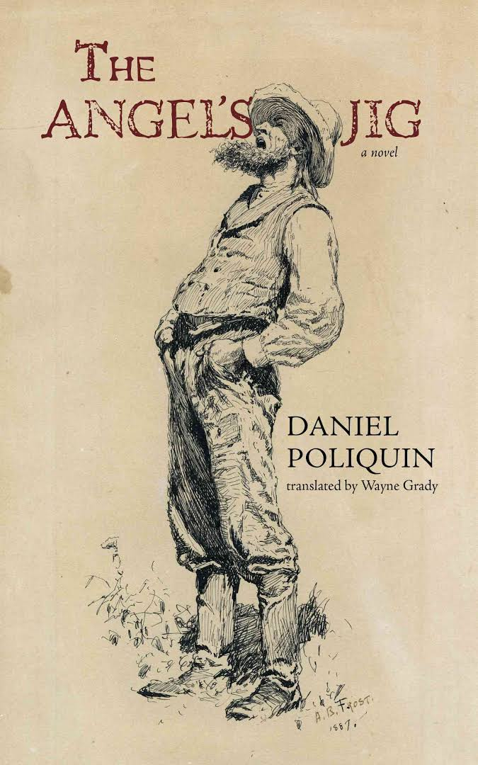  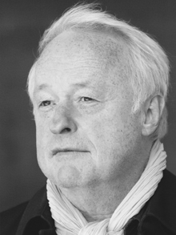 |  | Daniel Poliquin is one of Canada’s leading French writers. His novels and translations have won or been shortlisted for several major awards, including the Governor General’s Award, the Grand prix du Journal de Montréal, the Prix littéraire Le Droit, the Trillium Book Award, and the Giller Prize.  Join Daniel Poliquin for a discussion of his work, including The Angel’s Jig, an unforgettable novel which revisits an all-but-forgotten era, when orphaned children and the elderly poor were auctioned into a form of indentured servitude.
September 26, 2016 4:30pm- 5:30pm
University Hall D630
FREE ADMISSION (French and non-French speakers welcome)

