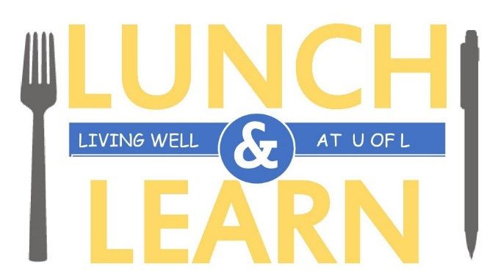

**Spooky Science**

**October 31 - 12:00PM – 1:00PM**

**Anderson Hall 137 (HR Department)**

**What**: The ***‘Let’s Talk Science Program’*** at the U of L will discuss the impact they have on Lethbridge and surrounding rural areas, as well as the National Let’s Talk Science organization.

There will also be FUN demonstrations and an educational activity (also FUN)!

**Hope to see you there!**

[**Register**](http://www.uleth.ca/hr/wellness/wellness-lunch-learns-registration)

**Or email:** [**wellness@uleth.ca**](mailto:wellness@uleth.ca)

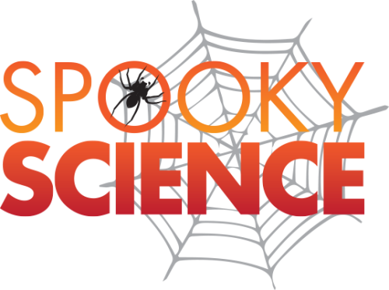

Light snacks will be available.

[**Register**](http://www.uleth.ca/hr/wellness/wellness-lunch-learns-registration) **Online or email:** [**wellness@uleth.ca**](mailto:wellness@uleth.ca)