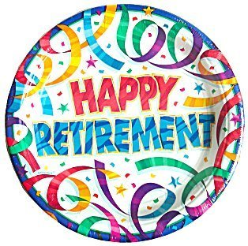
Retirement Farewell Celebration
for Elaine Carlson
AVP Human Resources and Administration

Monday, November 27, 2017
Andy’s Place, AH 100
3:00 pm – 5:00 pm

Human Resources & Payroll Offices will close at 3:00 pm
For more information, please contact Human Resources at 403-329-2274

