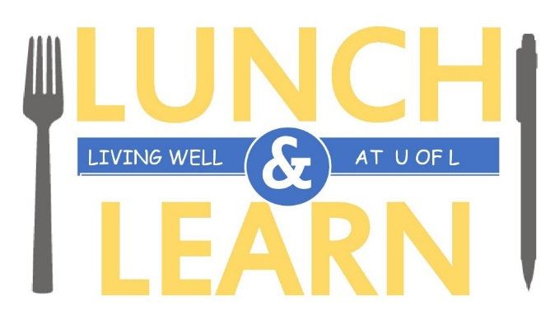

**Investing Basics**

**September 20 - 12:00PM – 1:00PM**

**Anderson Hall 137 (HR Department)**

**What**: Servus Credit Union is leading a session on investing. Trump’s in power- now what?  
Learn about the potential impact on Canadian Markets and what’s going on around the globe.

**Hope to see you there!**

[**Register**](http://www.uleth.ca/hr/wellness/wellness-lunch-learns-registration)

**Or email:** [**wellness@uleth.ca**](mailto:wellness@uleth.ca)



Light snacks will be available.

[**Register**](http://www.uleth.ca/hr/wellness/wellness-lunch-learns-registration) **Online or email:** [**wellness@uleth.ca**](mailto:wellness@uleth.ca)