**Construction Notice.**



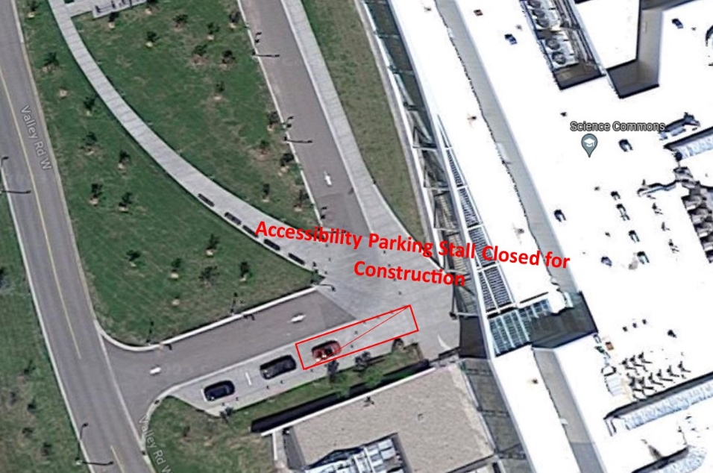

**Attention!**

Accessibility Stall Closed from

August 23rd to August 25th, 2023.

**Any concerns or questions?**

**Please contact:**

**Nicholas Solowoniuk**

**Project Management Office**

**Phone: 403-329-2712**