CAMPUS MOBILITY SERVICES (PARKING) TH101
(LEVEL 1) Turcotte Hall

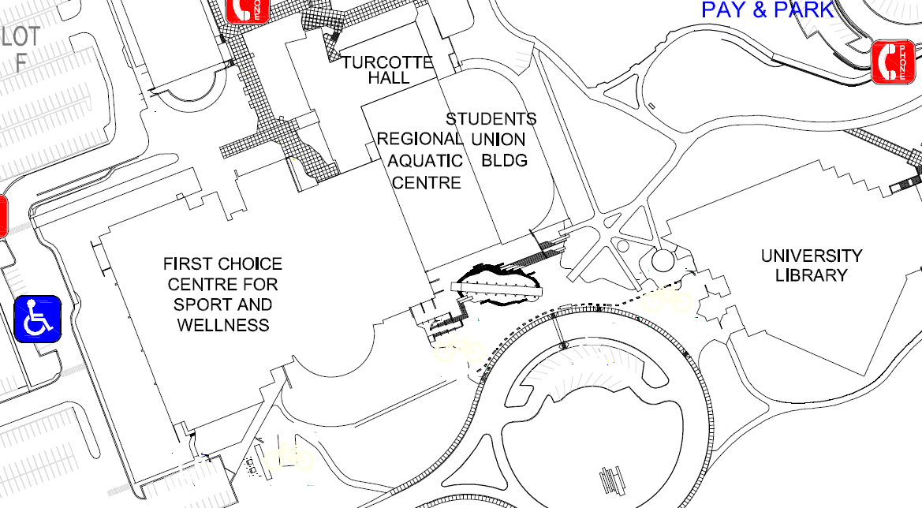

We Moved!
Campus Mobility Services (PARKING SERVICES) has been relocated to Turcotte Hall, Level 1
TH101
(403) 329-2602

