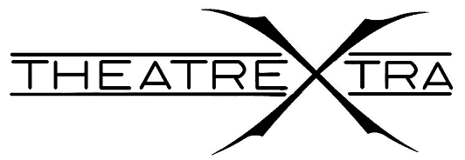
Audition Notice
Where’s My Sky?
Collective Creation
Directed By: Madeleine Taylor-Gregg and Elizabeth Ferguson

General Auditions
Monday, January 16th 5:00pm-8:00pm (B570)

Callbacks
Wednesday, January 18th 2017.4:30-7:00pm (W425)

Show Information
“Where’s My Sky is a theatrical collective creation that has the intention of posing more questions than it answers. The creative team, aspire to explore the question of fate, whether or not there may be a higher power, and each human’s purpose on earth.”

7 Performers

Audition Requirements
Perform a 1-minute memorized monologue, as well as a 2-minute creation piece based on the provided inspirational imagery

Please sign up for an audition slot on the bulletin board behind the box office (W522)
Students can receive portfolio credits for participation in TheatreXtra Shows
If you have any questions about the production or the company please email TheatreXtra Artistic Producers, Amelia Wills and Lyall Miller at theatre.xtra@uleth.ca
If you have any questions about auditions please email the stage manager, Kate Pallesen or either director
Kate Pallesen: kate.pallesen@uleth.ca
Madeleine Taylor-Gregg: taylorgreggm@uleth.ca
Elizabeth Ferguson: elizabeth.ferguson2@uleth.ca
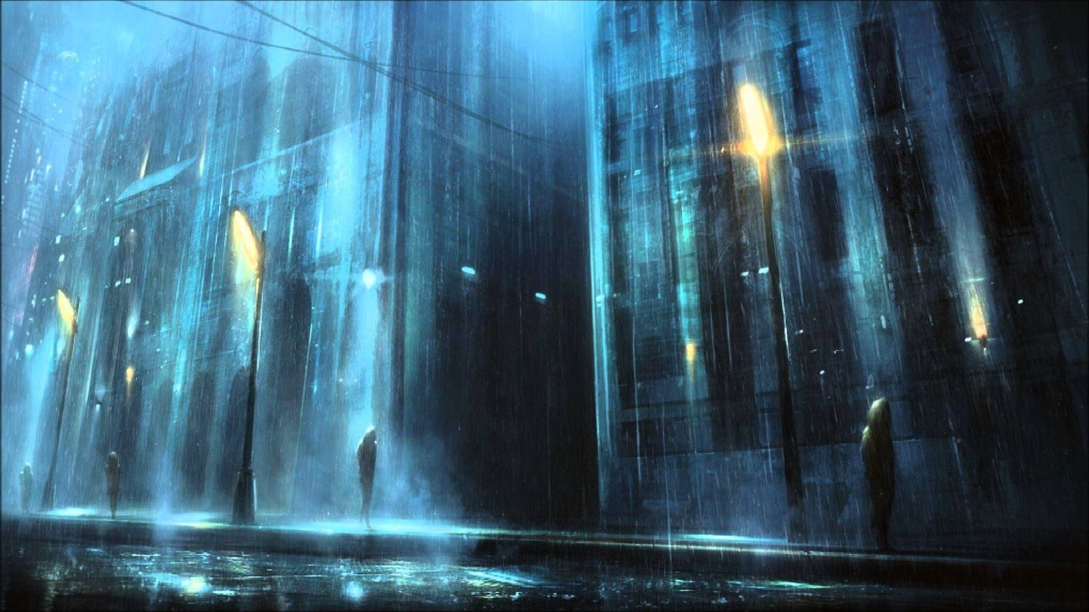Inspirational Imagery

